**CP Club 365 Days Challenge**

**Programming language – C++**

**Problem Statement**

[https://practice.geeksforgeeks.org/problems/spirally-traversing-a-matrix-1587115621/1?page=1&status[]=unsolved&curated[]=1&sortBy=submissions](https://practice.geeksforgeeks.org/problems/spirally-traversing-a-matrix-1587115621/1?page=1&status%5b%5d=unsolved&curated%5b%5d=1&sortBy=submissions)

Git :- <https://github.com/Vedantbharad2603/CP_club_365_Days>

**Your Code**:

// 0x113Day of 0x365Days challenge

// VEDANT BHARAD

// 7-2-2023

//{ Driver Code Starts

#include <bits/stdc++.h>

using namespace std;

// } Driver Code Ends

class Solution{

    public:

    //Function to return a list of integers denoting spiral traversal of matrix.

    // vector<int>

    vector<int> spirallyTraverse(vector<vector<int> > matrix, int r, int c){

        // code here

        vector<int> toret;

        int rs=0,re=r-1,cs=0,ce=c-1;

        while (rs<=re && cs<=ce){

            for (int i = cs; i <= ce; i++){

                toret.push_back(matrix[rs][i]);}

            rs=rs+1;

            for (int i = rs; i <= re; i++){

                toret.push_back(matrix[i][ce]);}

            ce-=1;

            if(rs<=re){

                for (int i = ce; i >= cs; i--){

                    toret.push_back(matrix[re][i]);}

                re-=1;

            }

            if(cs<=ce){

                for (int i = re; i >= rs; i--){

                    toret.push_back(matrix[i][cs]);}

                cs+=1;

            }

        }

        return toret;

    }

};

//{ Driver Code Starts.

int main() {

    int t;

    cin>>t;

    while(t--){

        int r,c;

        cin>>r>>c;

        vector<vector<int> > matrix(r);

        for(int i=0; i<r; i++){

            matrix[i].assign(c, 0);

            for( int j=0; j<c; j++){

                cin>>matrix[i][j];}

        }

        Solution ob;

        // ob.spirallyTraverse(matrix, r, c);

        vector<int> result = ob.spirallyTraverse(matrix, r, c);

        for (int i = 0; i < result.size(); ++i)

            cout<<result[i]<<" ";

        cout<<endl;

    }

    return 0;

}

// } Driver Code Ends

**Output (Screen Shot)**:

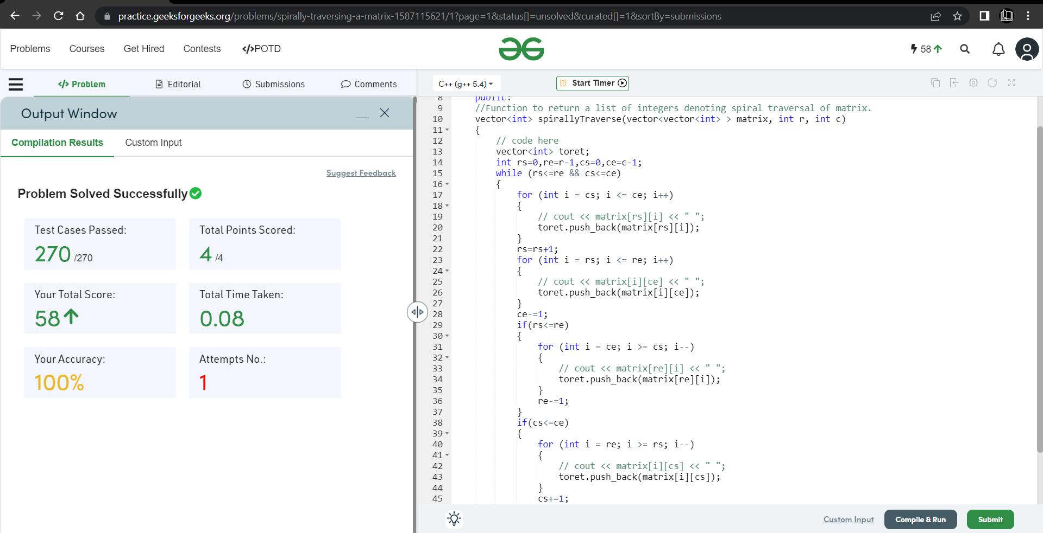

**Understanding about problem:**

* In this task there is one matrix and with that I need to traverse a matrix in Spirally and add that data in other vector and at last return that vector.

Note: If you can't understand the problem, feel free to contact us and we'll help you. Please don't copy and paste from anywhere.

ALL THE BEST

Team CP Club